27.06.22 Record Triggered Flows

Org: [agatanu7568@gmail.com](mailto:agatanu7568@gmail.com).flows

1. **Flow Name: Industry as Banking Update**

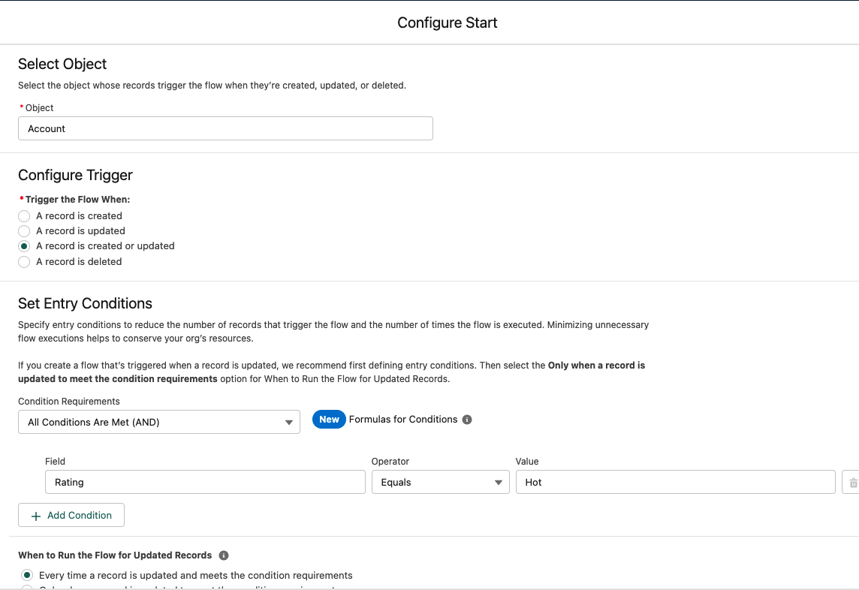

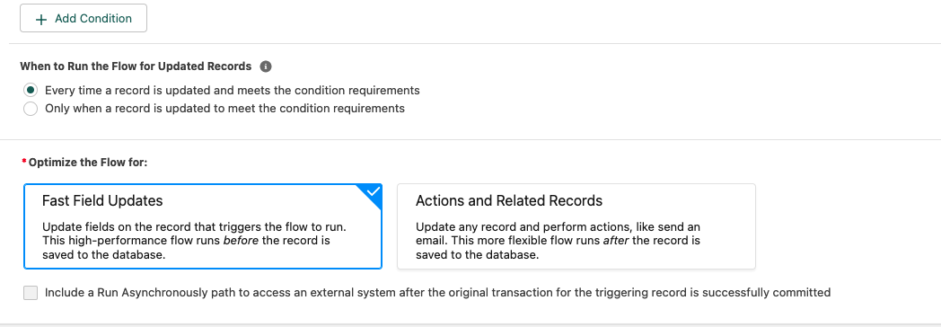

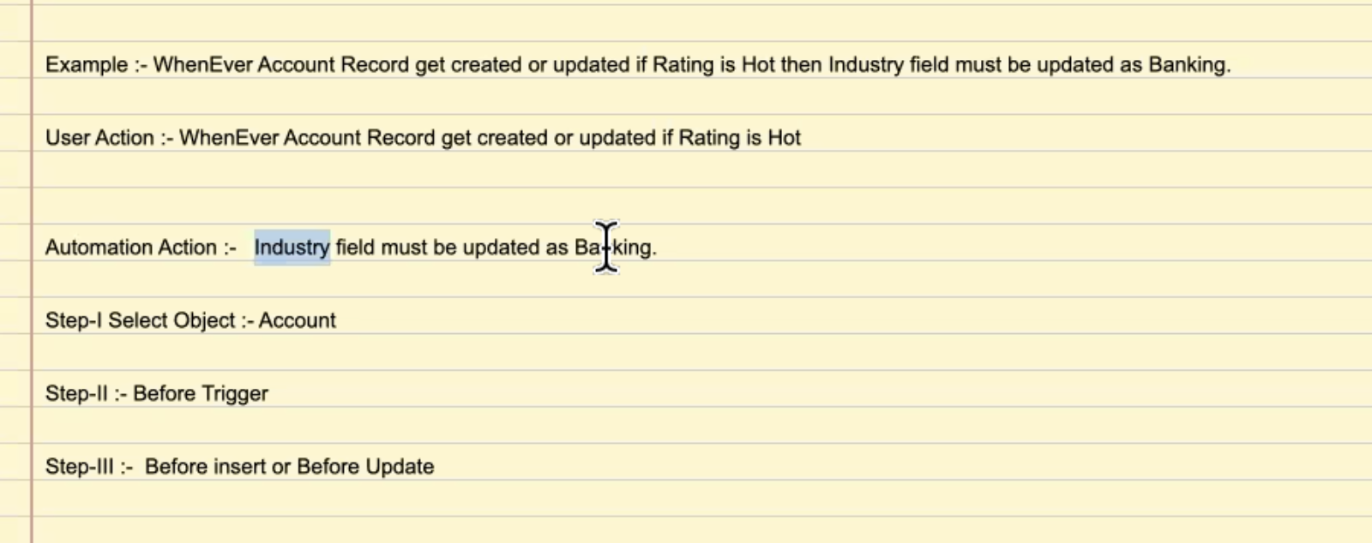

* Filter:

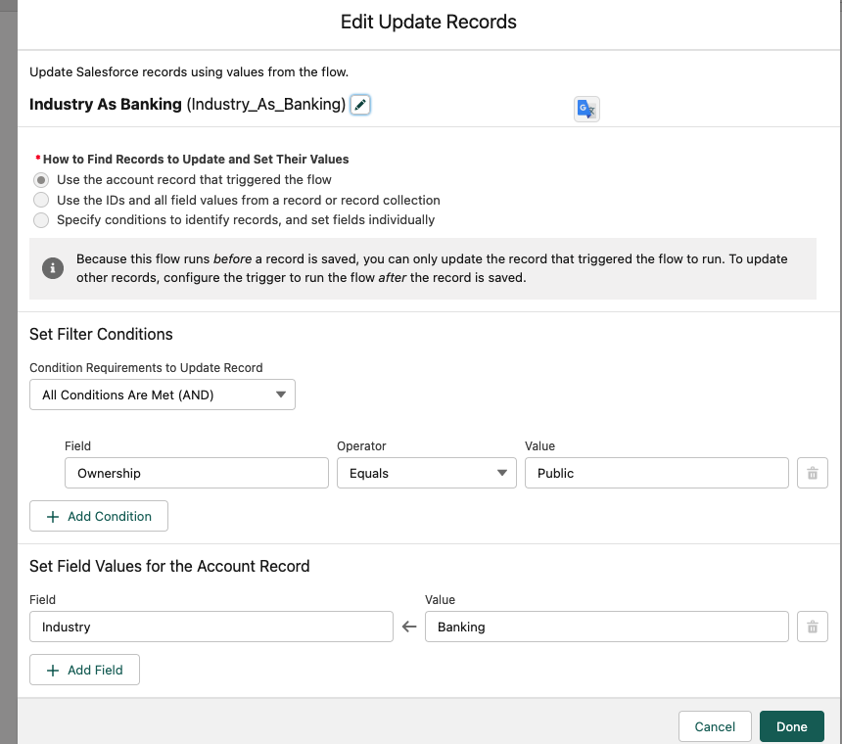

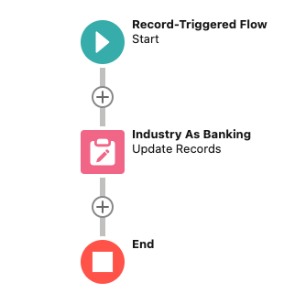

**2. Flow Name:Task Created on Opportunity.**

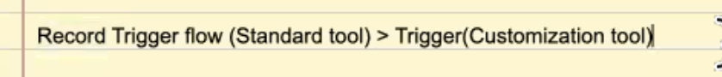

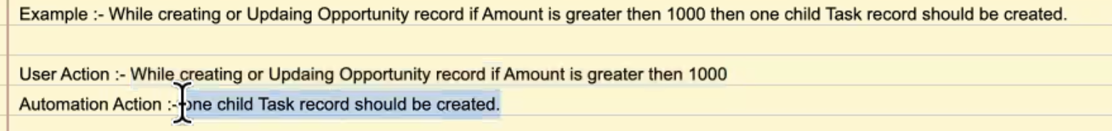

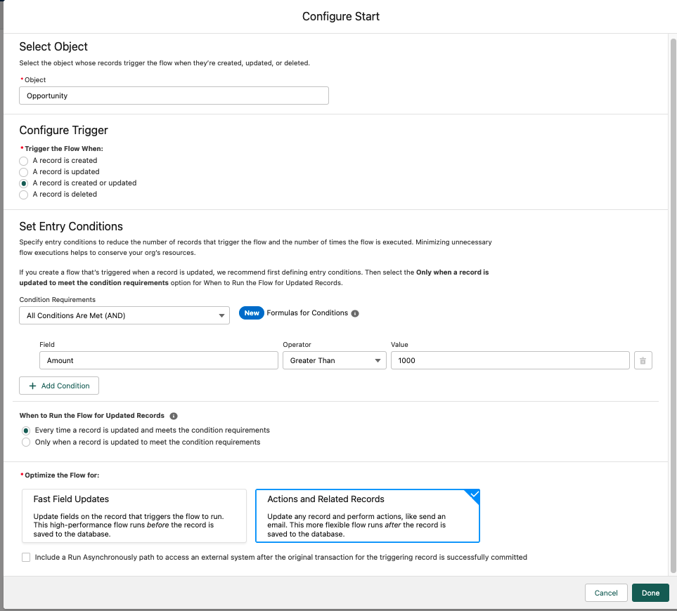

Whenever TWO OBJECTS ARE INVOLVED we use AFTER trigger.

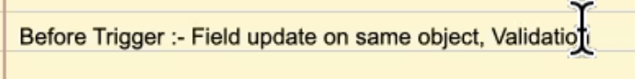

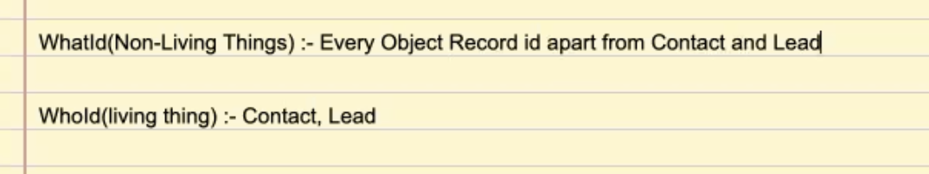

FLOW: Task Created on Opportunity on agatanu7568@...

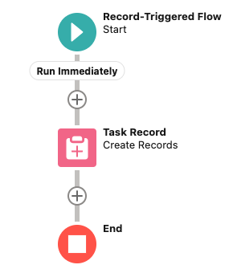

**3.Flow Name: Conditional Record Triggered Flow**

Example :- While creating only Account record if Rating is Warm and Ownership as Public then one child Opportunity record should be created and if rating is Cold and ownership is Private then one child contact record should be created. (edited)

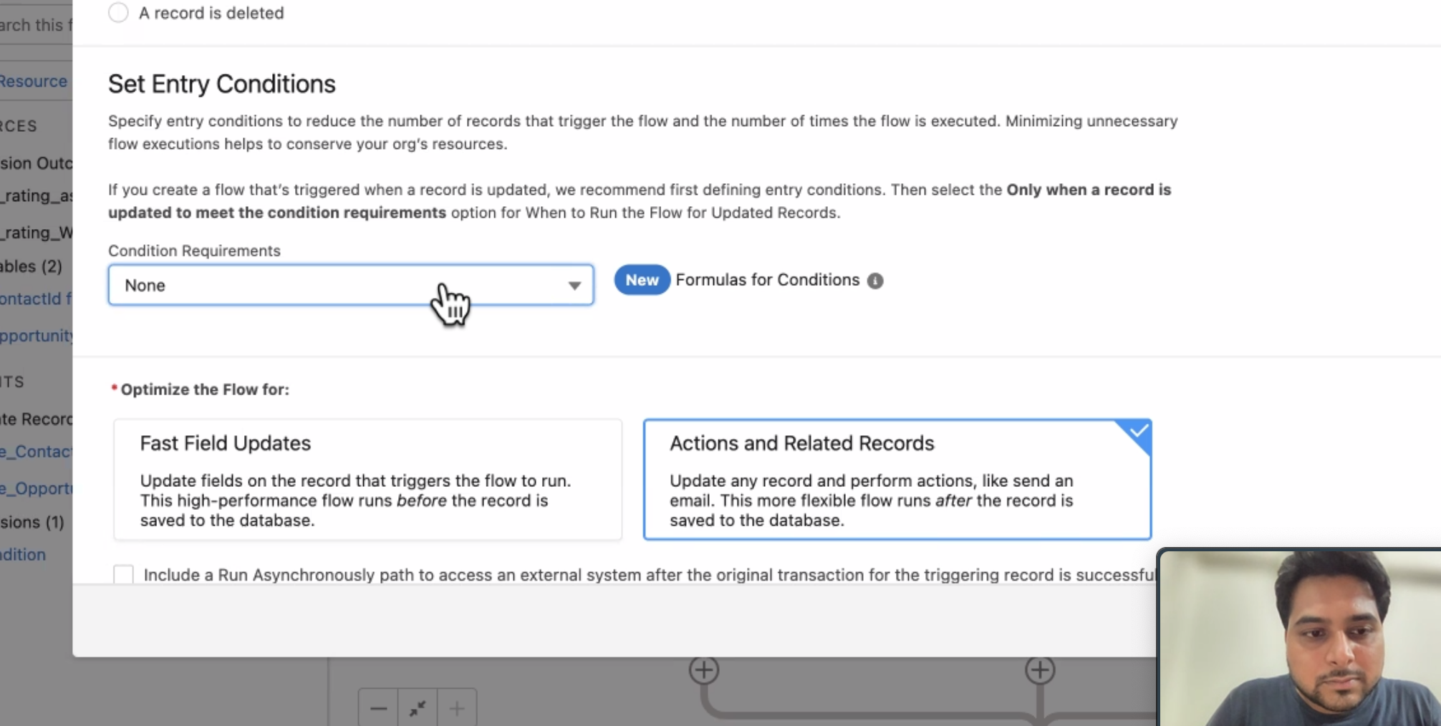

AND

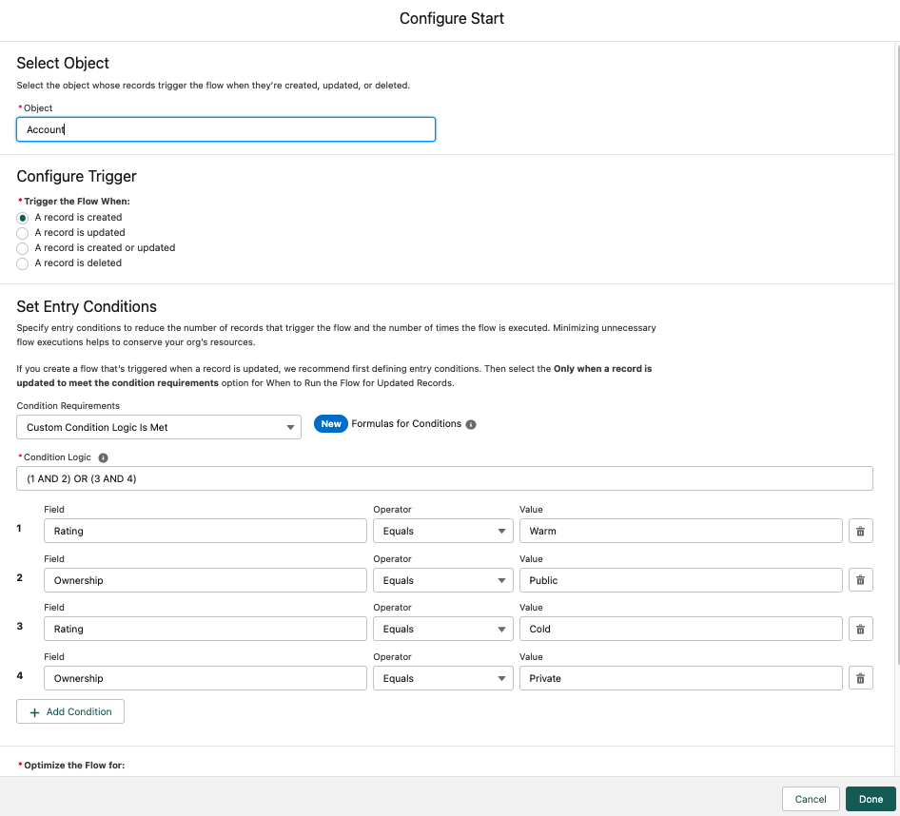

… ARE THE SAME . BUT the second one is more SECURE and BEST PRACTICE.

Both will work.

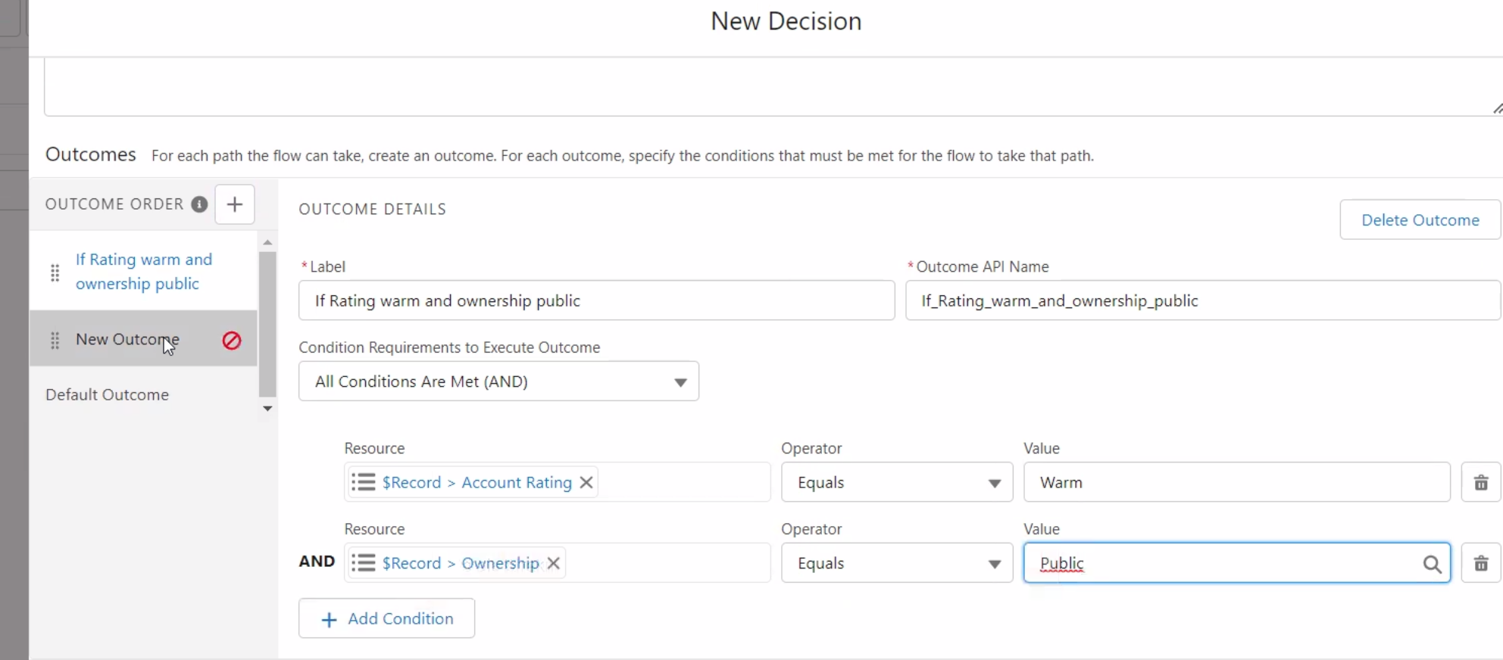

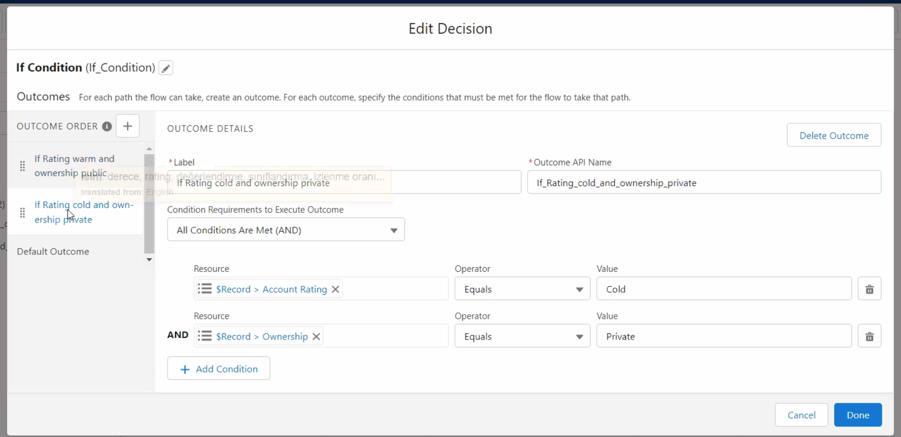

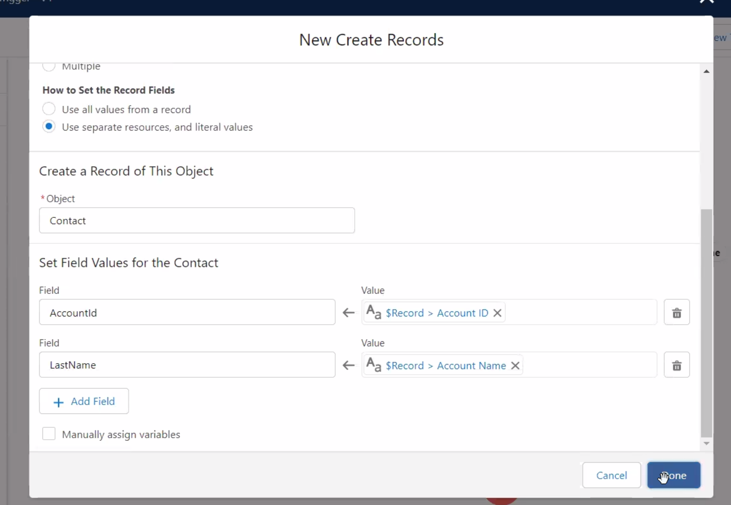

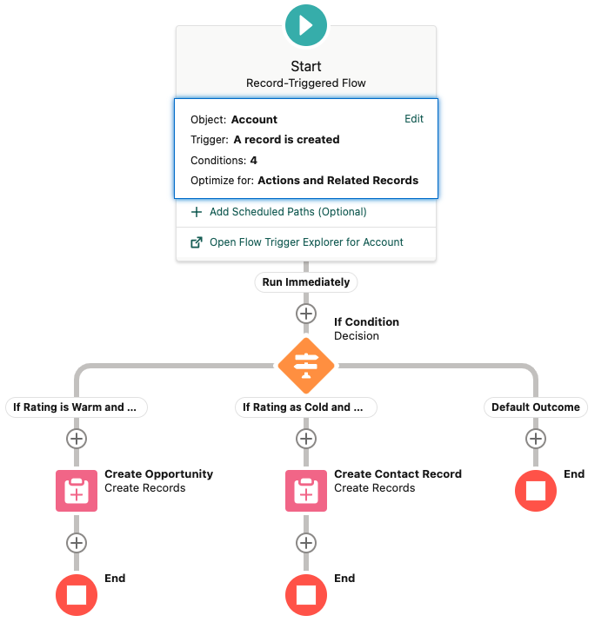

**4. Flow Name: Send Email Alert 27.06.22**

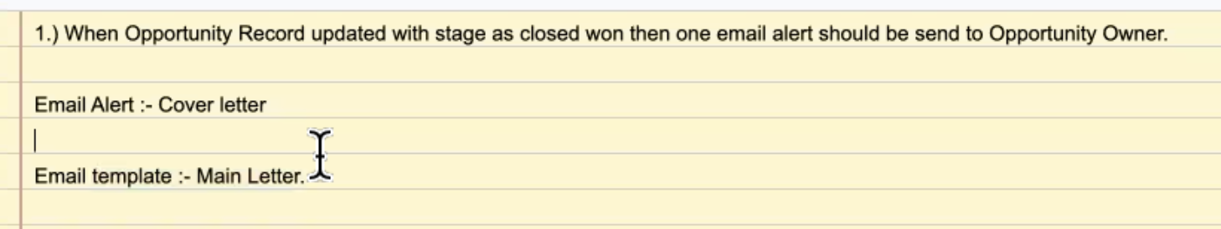

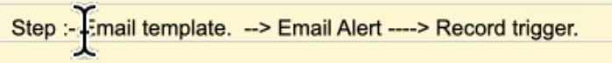

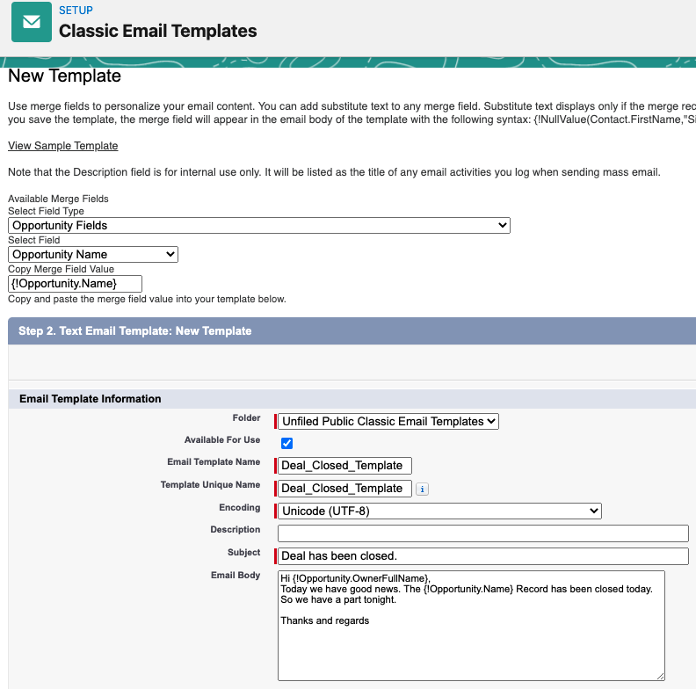

Save.

Setup->Email Alert:

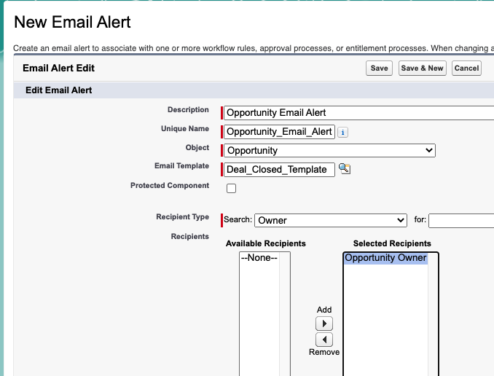

Save.

Go to Flows.

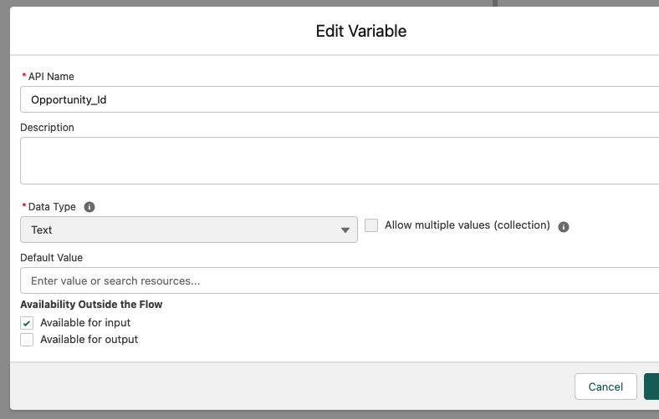

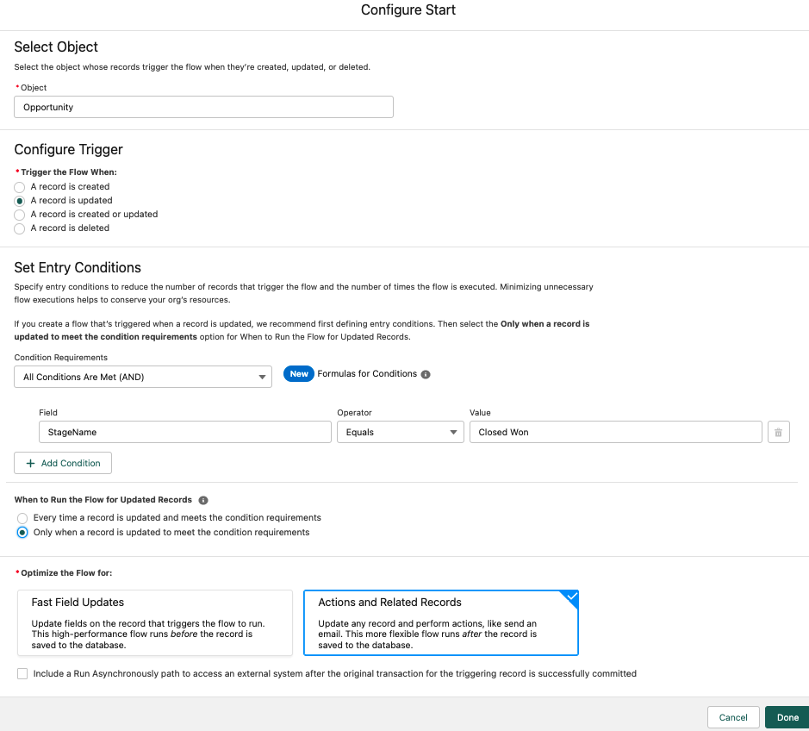

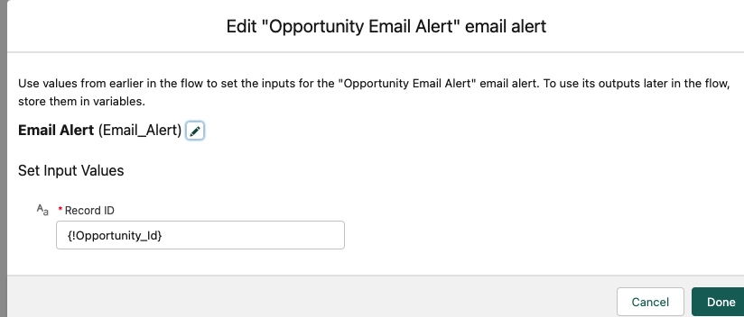

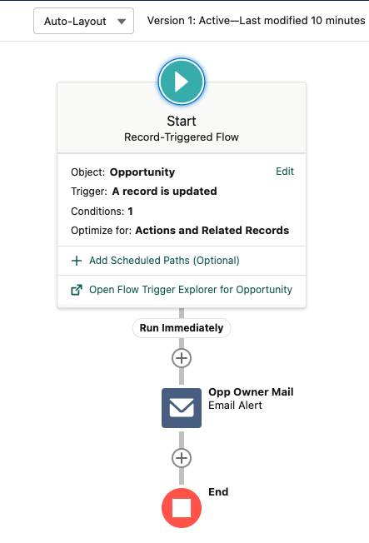

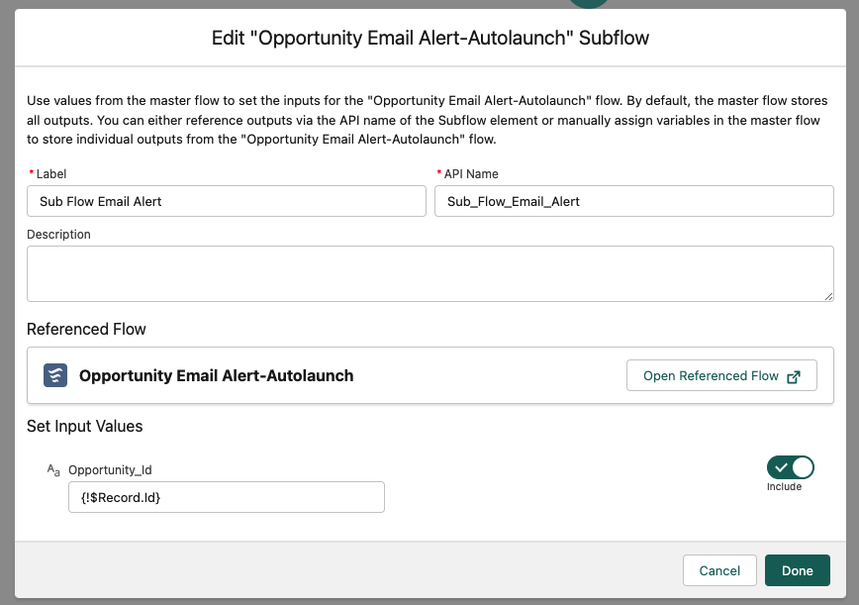

And after adding SubFlow:...

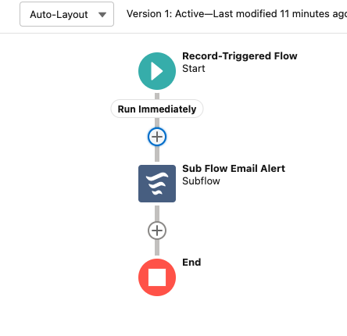

Send Email Alert V4

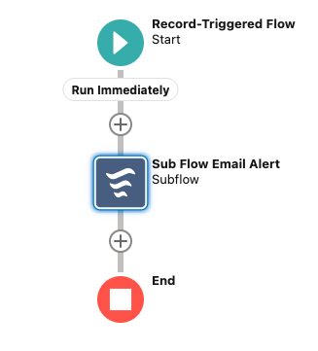**SeSekjfhgkjhkljahkljnSend Email Alert - V4**

**Send Email Alert - V4**